  For office use only
  T1 | ________________
  T2 | ________________
  T3 | ________________
  T4 | ________________
  Team Control Number
  49475
  Problem Chosen
  E
  For office use only
  F1 | ________________
  F2 | ________________
  F3 | ________________
  F4 | ________________

2016 Mathematical Contest in Modeling (MCM/ICM) Summary Sheet
Summary
Water scarcity has become exacerbated over the past century. How we can provide clean water to meet the demand of the whole population is now a pressing issue.
Firstly, in order to measure a region’s ability of providing clean water to meet the needs of the population, we developed an evaluation model which defines Water Stress Index (WSI). In our modeling process, we firstly selected the most influential factors including environmental drivers and social drivers by applying the attribute reduction algorithm. Then we established the formula of WSI based on the conditions of water supply and demand.
Secondly, we chose Lebanon as a study case, where water is heavily exploited. After data collection and preprocessing, we estimated the expressions of all the influential factors and displayed their dynamic changes during a specific time period and the correlations of the influential sub-factors by the method of curve fitting. Subsequently, we used the same method to get an overview of the water situation as well as the changes of WSI during the time. We further explained all the possible causes of water scarcity by addressing the environmental drivers and social drivers mentioned in the model of task 1.
Thirdly, we made a 15-year prediction of the water situation of Lebanon using the prediction model of grey forecasting and artificial neural network and the results are not optimistic. The resident in Lebanon will be suffering a lot from the decreasing water supply so further intervention plan are in pressing need to better the water supply situation in Lebanon.
Fourthly, we proposed a detailed intervention plan to assist in the decision-making of the Lebanese government. We firstly picked out all the possible indexes and created a preliminary plan. Then we made a sensitivity analysis of each index and evaluated their importance. Considering the current conditions, we improved our proposal and made an ultimate intervention plan.
In the final part, we analyzed the results of our intervention plan and compared the water supply situation with and without intervention by plotting a radar map, finding that the water scarcity will be mitigated. Then we concluded the strengths and weakness of our model.
Contents
1.Introduction 3
2 Symbols & Definitions 3
3 Assumptions 4
4 The Model 4
4.1 Model Overview 4
4.2 Introduction of WSI 5
4.3 A region’s water supply and demand 5
4.3.1 Water supply 5
4.3.2 Water demand 5
4.4 Attribute reduction based on real-valued information system 6
4.5 Expression of WSI 8
5 A Case study on the Republic of Lebanon 9
5.1 Introduction of the Republic of Lebanon 10
5.2 Data preprocessing 11
5.3 WSI in Lebanon 11
5.3.1 Curve fitting 11
5.3.2 WSI in Lebanon 14
5.4 Explanations for water scarcity 14
5.5 A 15-year forecast of water situation 15
5.5.1 Introduction of the prediction algorithms 15
5.5.2 Prediction results 15
5.5.3 Predicted situation and future impact 17
6. Intervention Plan 17
6.1 Effectiveness judgment by sensitivity analysis 17
6.2 Reasonability judgment based on actual conditions 18
6.3 Ultimate intervention plan 19
7. Comparison and Evaluation 19
8. Analysis of the model 20
8.1 Strengths 20
8.2 Weakness 21
Reference 21

1.Introduction
Water problems have become a global concern over the last century. Water scarcity is the lack of sufficient available water resources to meet water needs within a region. It affects every continent and around 2.8 billion people around the world at least one month out of every year. More than 1.6 billion people lack access to clean drinking water.
Throughout the history, we cannot ignore the great achievement and wisdom of human beings fighting against water scarcity. The construction of Hoover Dam in the United states, the Project of Panama Canal and the water-saving agriculture in Israel. They all succeeded in meeting the water demand of its resident.
There are two main causes for water scarcity: physical scarcity and economic scarcity. There are also two major drivers of the water supply and demand: environmental drivers and social drivers. If a model of water scarcity is developed including all the possible drivers, maybe we will get the key to solving water problems.

2 Symbols & Definitions
Variable Symbols | Definition
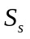 | Mean annual surface water supply of a region
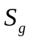 | Mean annual ground water supply of a region
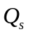 | Quantity of surface water of a region
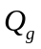 | Quantity of ground water of a region
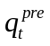 | Quantity of average annual precipitation of a region
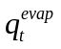 | Quantity of average annual evaporation of a region
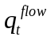 | Quantity of average annual stream flow of a region
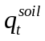 | Quantity of average annual soil water of a region
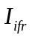 | Annual government investment in water-related infrastructure of a region
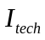 | Annual government investment in technology
 | Mean annual temperature of a region
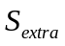 | Annual water supply in extra forms of a region
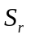 | Mean annual reclaimed water supply of a region
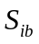 | Water supply of annual inter-basin water diversion of a region
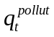 | Mean annual polluted water of a region
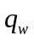 | Mean annual waste water of a region
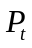 | Annual total population in a region
 | Annual water demand per capita of a region
 | Annual GDP of a region
 | Annual total primary industrial output value of a region
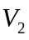 | Annual total secondary industrial output value of a region
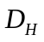 | Annual water demand in households of a region
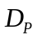 | Annual water demand in production of a region

3 Assumptions
❐ The data we collected from the references accurately reflect the actual situation;
❐ There are no dramatic changes of the world’s climate and population from 2016 to 2030;
❐ There are no dramatic changes of the Lebanon’s climate and population from 2016 to 2030;
❐ The natural water resources only consist of the surface water, the ground water and the reclaimed water;
The water demand only consists of the demand in households and the demand in production;
We ignored the changes of reclaimed and water waste water in Lebanon in the year of 1999-2030.

4 The Model

4.1 Model Overview
In this part, we developed an evaluation model which defines WSI——Water Stress Index. In our modeling process, we firstly selected the most influential factors including environmental drivers and social drivers by applying the attribute reduction algorithm. Then we established the formula of WSI basing on the conditions of water supply and demand.

4.2 Introduction of WSI
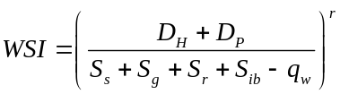
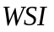is the water stress indicator which measure the severity of water scarcity in a specific region.

4.3 A region’s water supply and demand

4.3.1 Water supply
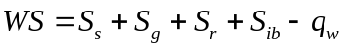

Figure 1.Water supply
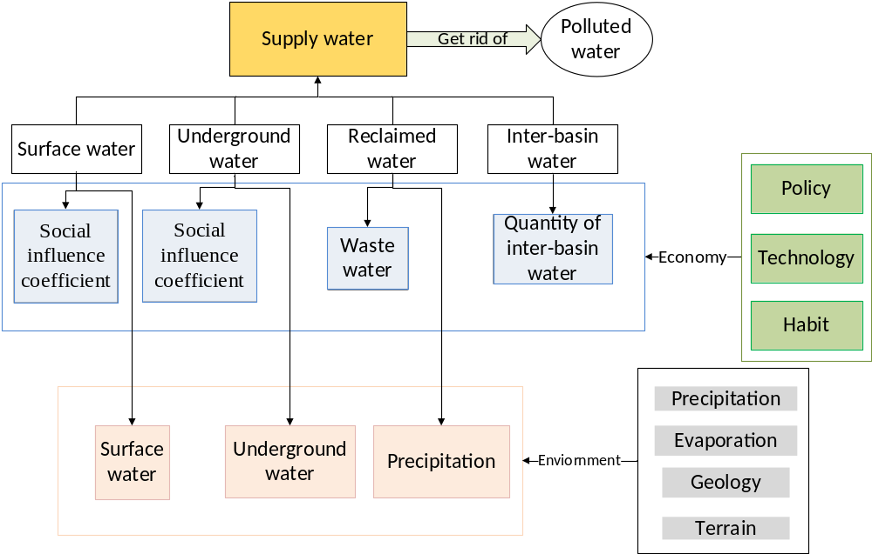
,

4.3.2 Water demand
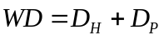

Figure 2.Water demand
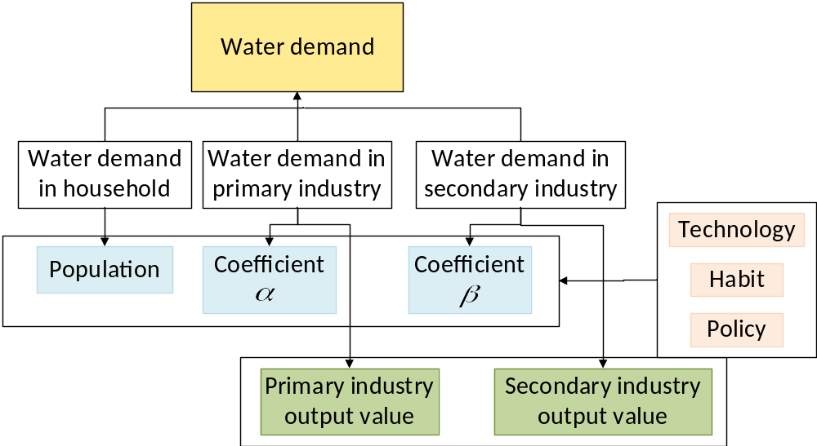

4.4 Attribute reduction based on real-valued information system
We select all the possible influential factors based on the references we have read and studied and the discussion of water supply and demand. The table is as below:

Table 2.Possible influential factors
index | Definition | Explanation
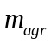 | Annual agricultural output | A monetary measure of the value of all the products in agriculture
 | Annual total primary industrial output value of a region | A monetary measure of the value of all the products in primary industry.
 | Annual total secondary industrial output value of a region | A monetary measure of the value of all the products in secondary industry.
 | Annual GDP of a region | GDP is a monetary measure of the value of all final goods and services produced in a period (quarterly or yearly).
 | Water supply of Inter-basin water diversion of a region | Water supply from one river basin where it is available, to another basin where water is less available
 | government investment in water-related infrastructure | Annual government investment in water-related infrastructure of a region
 | government investment in water-related technology | Annual government investment in water-related technology of a region
 | Quantity of average annual precipitation of a region | Precipitation is any product of the condensation of atmospheric water vapour that falls under gravity
 | Quantity of average annual evaporation of a region | Evaporation is a type of vaporization of a liquid that occurs from the surface of a liquid into a gaseous phase that is not saturated with the evaporating substance.
 | Quantity of average annual river flow of a region | Stream flow is the flow of water in streams, rivers, and other channels, and is a major element of the water cycle.
 | Quantity of average annual soil water of a region | The quantity of water in every 100 gram dry soil
 | Temperature | Mean annual temperature of a region
 | Water supply in extra forms of a region | The other kinds of supply that didn’t mention before
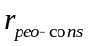 | The increasing rate of individual consumption | The increasing rate of products that people consummated to meeting their needs for variety of material life, labor and spirit.
 | Population | Annual total population in a region
 | Annual water demand per capita of a region | The total water demand over the total population
 | Quantity of waste water | Mean annual waste water of a region
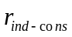 | The growth rate of industrial consumption | The growth rate of the number of required labor, material and other consumption in processing products.
We collected data through UN official website and apply the attribute reduction algorithm introduced above and selected the most influential factors.

Input: An information system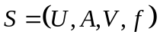, where 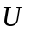 is the domain,  is an attribute set.

Output: The core and reduction of the information system.

Step1: Calculate the information quantity 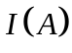in the information system.

Step2: Calculate the significance of every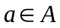, which is denoted as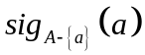. Let 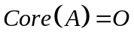 if the value of is not 0, then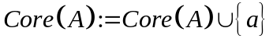, finally we get 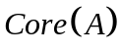as the core of the attribute set.

Step3: Let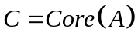, we repeat the following process for attribute set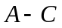:
- For every attribute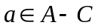, calculate the value of 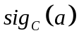.
- Select an attribute A which holds the following equation:
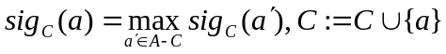,
- If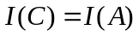, then the process is end (Meanwhile  will be an approximate
reduction of). Otherwise, go to (1).
The calculated result of information quantity 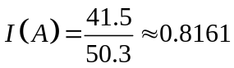，where A is an attribute set. After calculating the significance of every attribute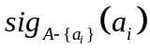, we get the equation below:
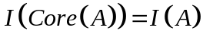
Therefore, 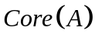 is a minimal reduction of the system:
Thus, the elements that contains are the eventual establishment of the index system.

4.5 Expression of WSI
Based on the discussions of water demand and supply and the attribute reduction method, we now define the matching degree of a region:

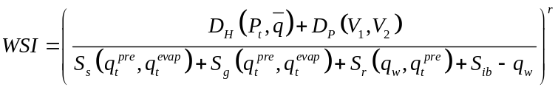.
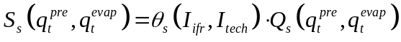.
is the quantity of surface water. 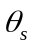 is the social influential coefficient of surface water measured by the government investment in water utilization project and the level of technology development. and are supposed to be related to the water situation such as the quantity of surface water , ground water and reclaimed water of the region.
.
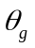 is the social influential coefficient of ground water which is also measured by the government investment in water utilization project 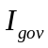 and the level of technology . is the quantity of ground water.
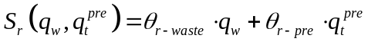.
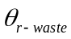 is the social influential coefficient of reclaimed water from polluted water. 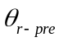 is the social influential coefficient of reclaimed water from rainwater. They are all set to be constants.
and are supposed to be constants in a certain year for a certain region.
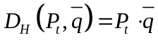
is the annual total population in a region, is the annual water demand per capita of a region which is supposed to be a constant.
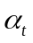 and 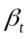 are coefficients of annual total primary industrial output value and annual total secondary industrial output value respectively.
is the attitude parameter and the diagram below shows their impact on the matching degree.

Figure 3.Influence of the attitude parameters
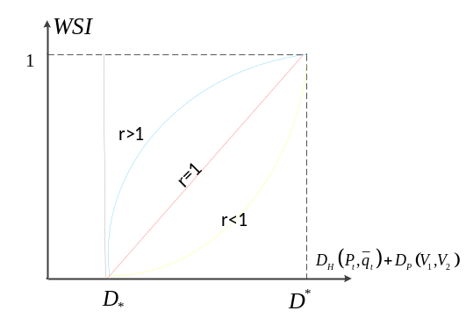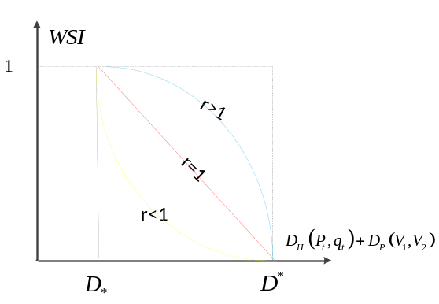

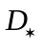 is the minimum of the water demand and 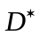 is the maximum of the water demand. As we can obtain from the diagram, when changes around 1 the growth trend remains at the approximately same level.

5 A Case study on the Republic of Lebanon
In this part, we selected Lebanon as a study case where water is heavily exploited. To start with, we gave a detailed overview of the geography and climate as well as the economic and social conditions of Lebanon. After data preprocessing, we made a fitting equation of the water resources, water supply, water demand and other significant influential factors. Subsequently we obtained the matching degree in Lebanon and further explain the possible causes of water scarcity according to the model we developed. Finally we made a 15-year prediction, only to find that the water situation will be more serious.

5.1 Introduction of the Republic of Lebanon
Geography and climate
- Lebanon is located in Western Asia between latitudes 33° and 35°N and longitudes 35° and 37°E at the crossroads of the Mediterranean Basin and the Arabian hinterland
- The country's surface area is 10,452 square kilometers (4,036 sq mi) of which 10,230 square kilometers (3,950 sq mi) is land.
- Lebanon is divided into four distinct physiographic regions: the coastal plain, the Lebanon mountain range, the Beqaa valleyand the Anti-Lebanon mountains.

Figure 4.Terrain of Lebanon
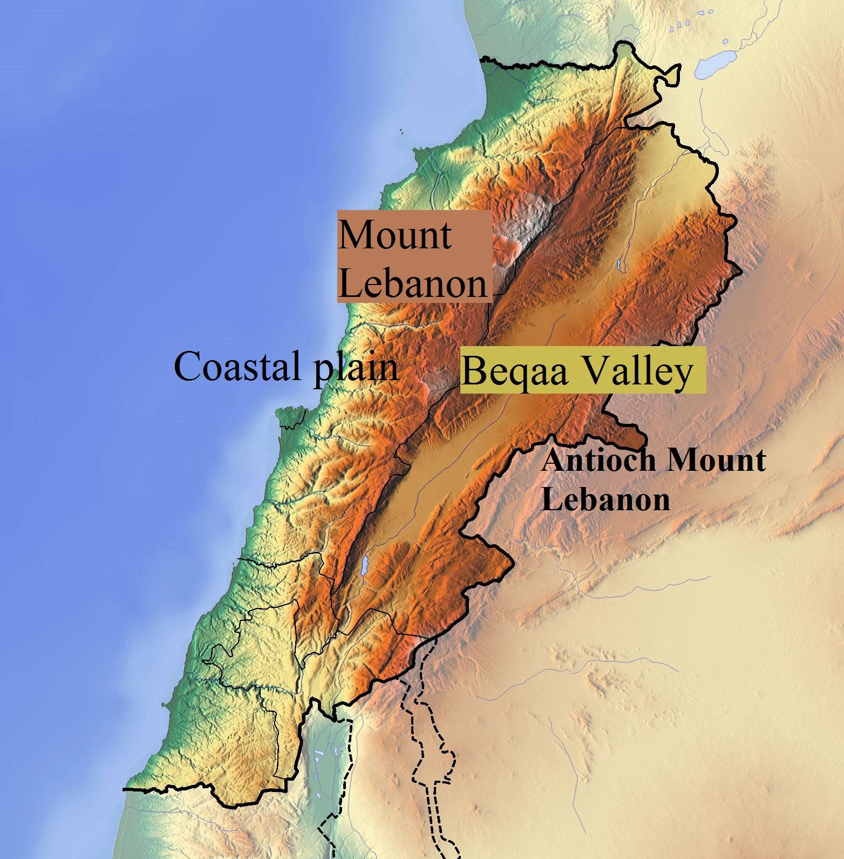
- Lebanon has a moderate Mediterranean climate. In coastal areas, winters are generally cool and rainy whilst summers are hot and humid. In more elevated areas, temperatures usually drop below freezing during the winter with heavy snow cover that remains until early summer on the higher mountaintops.
- The country's per capita renewable water resources are below the threshold of water poverty set at 1,000 cubic meter per capita and year. Only part of the floodwater in rivers can be captured economically in dams, and some groundwater flows unused to the sea.
- Springs and groundwater are today by far the main sources for drinking water supply in Lebanon
Economic and social conditions
- Lebanon’s economy follows a laissez-faire model.
- Lebanon has a very high level of public debt and large external financing needs.
- Industry in Lebanon is mainly limited to small businesses that reassemble and package imported parts.
- Industry in Lebanon is mainly limited to small businesses that reassemble and package imported parts.
- The Syrian crisis has significantly affected Lebanese economic and financial situation.

5.2 Data preprocessing
Data resources:
Considering the evolution of population, per-unit water demand, irrigated areas, water supply network efficiency, as well as the evaluation of a biological flow, we collect the data of the environmental conditions, water resources, climate change, economic development of Lebanon from the websites of UN and World Resources Institute in. We notice that the water conservancy sector in Lebanon was in a laissez-faire model so the data of political factors influencing the water supply is not available. We only collect the data from 2001 to 2009.
The whole data preprocessing progress
- All the data are from the government official websites and other authorized websites ensuring the supplied data are “clean, correct and useful”.
- The unit of water is uniformed and stimulated for billion cubic meter.
- Missing data, unavailable records and outliers of the data are abandoned.
- The latitudes and longitudes data which are beyond the borderline of the physiographic regions are removed.

5.3 WSI in Lebanon

5.3.1 Curve fitting

Figure 5. Fitting of the surface water
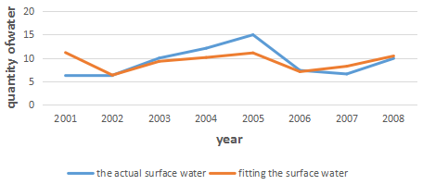
Fitting function

Figure 6. Correlation diagram of surface water and ground water
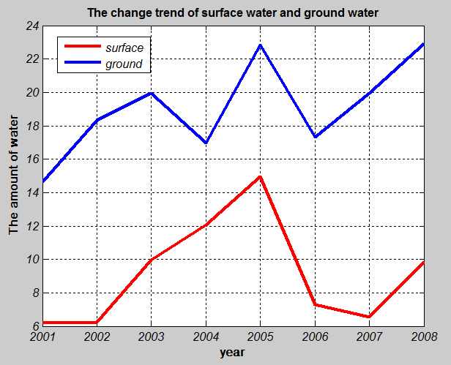
The fitting function:
Figure 7.Fitting of Figure 8. Fitting of
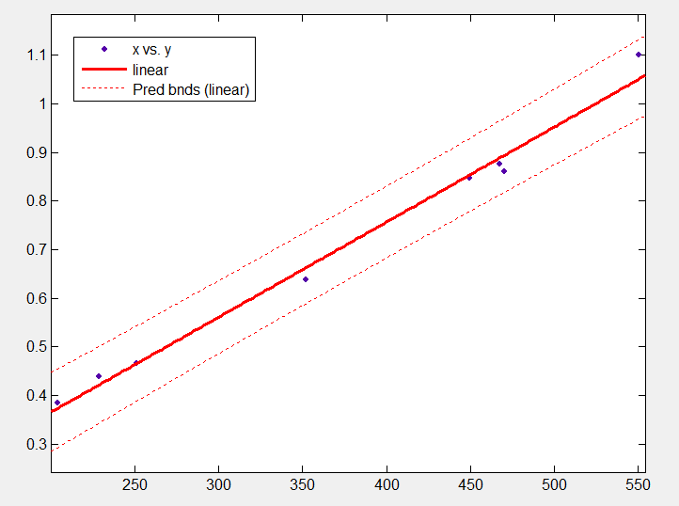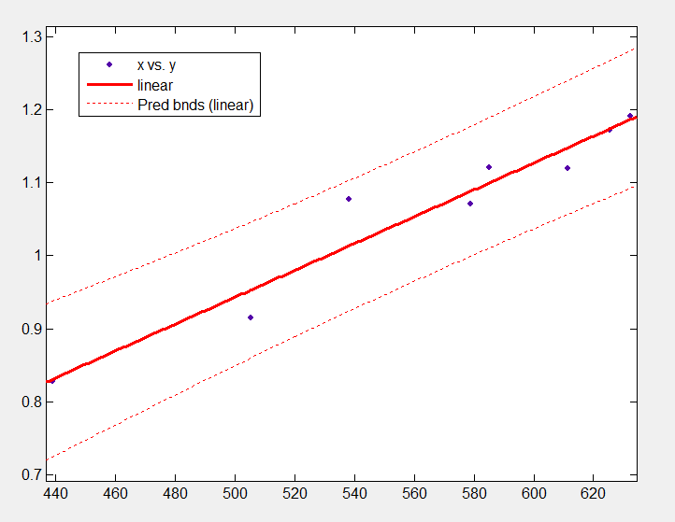
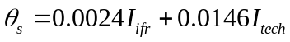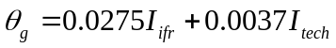
Figure 9. Fitting of the population
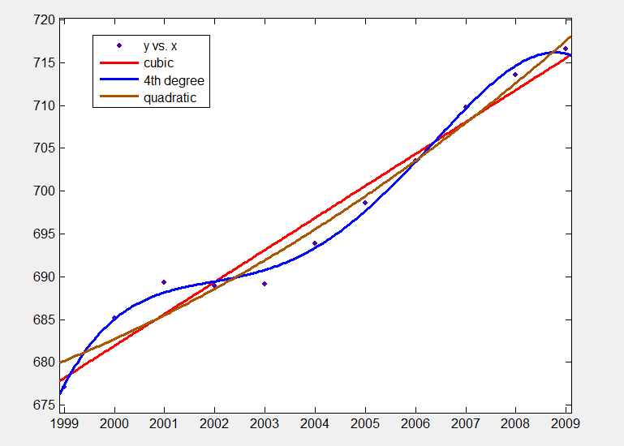
Figure 10. Fitting of
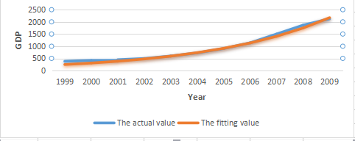
The fitting function: 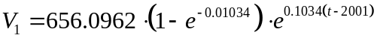
Figure 11. Fitting of
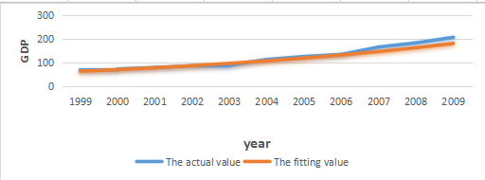
The fitting function: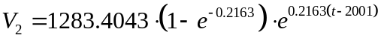
Figure 12. Fitting of Figure 13.Fitting of
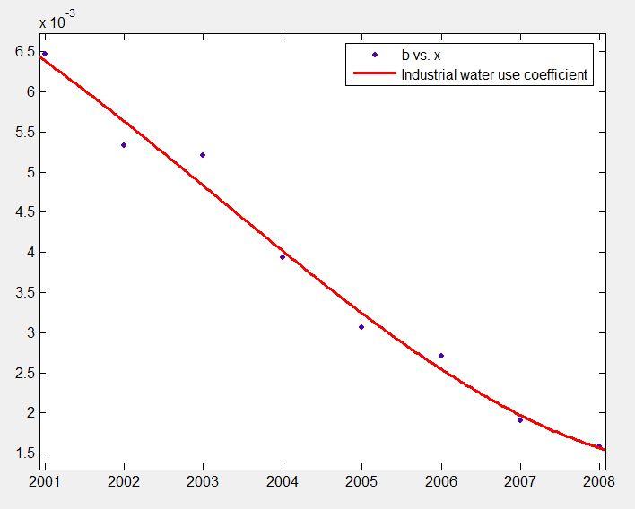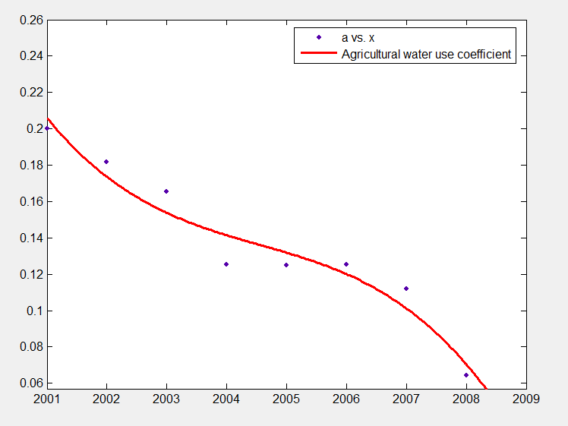
The fitting functions:
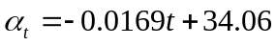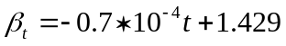
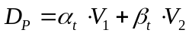
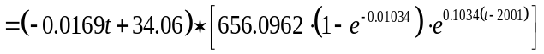

5.3.2 WSI in Lebanon

Figure 14.WSI
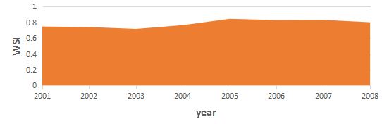
The diagram shows the WSI of Lebanon fluctuating at a high level with value near 0.8. In other word, Lebanon suffers deficiency of water supply in meeting its water demand.

5.4 Explanations for water scarcity
Water scarcity is one of the most pressing issues in the country.
Lebanon is abundant in water resources and the physical scarcity is not apparent in the country. Water scarcity is largely due to the economic scarcity with both the environmental and social drivers.
Environmental pollution, destroyed ecosystem and unavailable water resources are the environmental driver of water scarcity. While there are large areas of surface water, the environmental pollution and destroyed ecosystem is largely due to the unsustainable development of human activities. Besides, Some water resources are in the snow of mountaintops or remains in the deep layer of lithosphere which are unavailable to utilize.
The social drivers including poor government performance, poor service quality, the slow implementation of the technology reform, a high level of water distribution losses slow GDP growth and high population rates persist in the availability of water supply.

5.5 A 15-year forecast of water situation

5.5.1 Introduction of the prediction algorithms
·Grey forecasting technique
Grey forecasting is the method to forecast changes on the characteristic value of system behavior by using GM(1,1) model. Generally speaking, it consists of formation of grey, modeling of grey and check on posterior error.
·Artificial Neural Network
In recent years, ANN have received great attention in many aspects of scientific research and have been applied successfully in various fields such as chemical processes, digital circuitry, control systems, etc, for ANN provide a mechanism for adaptive pattern classification. Even in unfavorable environments, they can still have robust classification. It should be stressed that choosing a suitable ANN architecture is vital for the successful application of ANN.

Figure 15.BP ANN

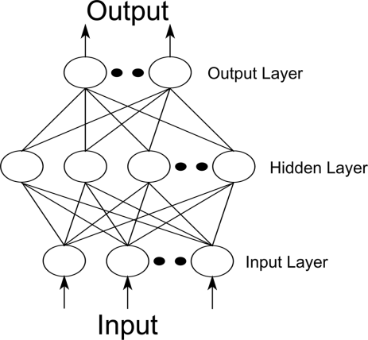

BP network has strong nonlinear mapping ability, a three layer BP neural network can realize the arbitrary nonlinear function approximation (according to the theorem of Kolrnogorov ).A typical three layer BP neural network model are shown in the figure above.

5.5.2 Prediction results
WSI is defined by the indexes of water supply and demand. We need to establish a forecasting model for every influential factor respectively then get an overview of the value of WSI as well as the changing conditions of water supply and demand through the years basing on the equations in 4.2.
The prediction results are showed in the diagrams below:

Figure 16. Prediction of the surface water
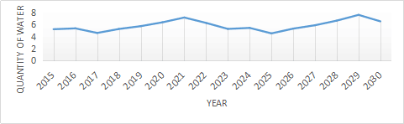

Figure 17. Prediction of the ground water
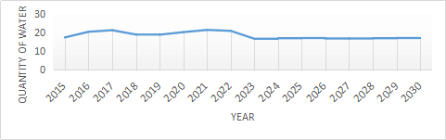

Figure 18. Prediction of the population
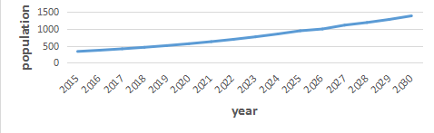
Figure 19. Prediction of the population
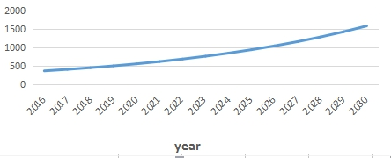

Figure 20. Prediction of the population
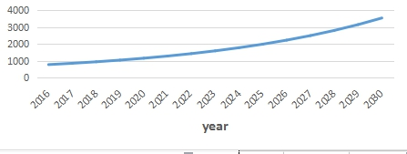

Figure 21. Prediction of WSI

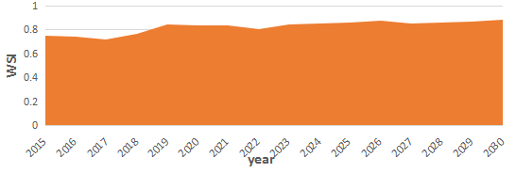

5.5.3 Predicted situation and future impact
The prediction diagrams in 5.5.2 indicate that the water resources remain approximately on the same level and both of and will increase. However, the population will be faced with a more rapid increase and the value of WSI will be over 0.8. Therefore, there will be a more serious water scarcity in Lebanon. The environmental driver such as the environmental pollution will add to the quantity of waste water thus reduces the quantity of water supply and the lives of local resident will be under threat. The social driver like and are supposed to be constant so the clean water obtained from the water resources will be restrained.

6. Intervention Plan

6.1 Effectiveness judgment by sensitivity analysis
Sensitivity analysis is always used to test the robustness of a model. And we invoke sensitivity analysis to evaluate the ability of each index to influence the results. In other word, we rank indices decreasingly by absolute value of difference quotient by index of matching degree =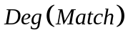 as
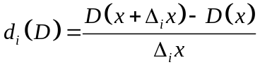,
Where represents origin data, and 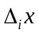 is the variation of index .
Using this approach, we obtain the effective indices list for Lebanon in Table 3, and Figure 4 shows the results of each index.

Table 4.Effective indices list
1 | Agricultural output | 7 | Primary industrial output | 13 | Secondary industrial output
2 | GDP | 8 | Inter-basin water diversion | 14 | Precipitation
3 | Evaporation | 9 | Flow water | 15 | Government investment
4 | Technology index | 10 | Soil water | 16 | Temperature
5 | Extra water supply | 11 | Population
6 | Waste water | 12 | Water demand
Based on these influential indices, we propose some possible directions for our final plan as follow:
⧫ Reduce consumption (Indices 11, 12)
⧫ Save natural resources (Indices 3, 9, 10, 14, 16)
⧫ Modernization support (Index 4)
⧫ Extra supply (Index 5, 6)
⧫ Economic assistance (Indices 1, 2, 7, 13, 15)
⧫ Political assistance (Index 8)

Figure 22.Sensitivity of each index


6.2 Reasonability judgment based on actual conditions
Given that our model provides several rough directions of our plan, it remains to refine and substantiate them by reality. To this end we list some basic characteristic of Lebanon:
Lebanon’s economy follows a laissez-faire model. Lebanon has a very high level of public debt and large external financing needs. The 2010 public debt exceeded 150.7% of GDP, ranking fourth highest in the world as a percentage of GDP, though down from 154.8% in 2009. Lebanon has been ranked globally as a remarkable country for education, and as the tenth best overall for quality of education, which means Lebanese have a great ware of saving resources. Also government has taken many kinds of policies to protect environment. Based on the cases, we get:

Table 5.Possible proposal trade-off
Possible Plan | Actual Requirement |  |  | Demands | Decision
Possible Plan | Cost | Political stability | Resource | Demands | Decision
Reduce consumption | Medium | Flexible | \ | Medium | Accepted
Save natural resources | High | Medium | \ | Medium | Accepted
Modernization support | High | Medium | Medium | High | Accepted
Extra supply | Flexible | Low | Flexible | Low | Rejected
Economic assistance | High | High | Flexible | High | Accepted
Political assistance | Flexible | Medium | Medium | High | Accepted

6.3 Ultimate intervention plan

We propose our intervention plan for Republic of Lebanon:
Ⅰ. Reduce consumption & Save natural resources
The implementation of the plan is restricted by the citizen’s awareness of conservation thus is related to the educational development. There is one public university and 28 private universities in Lebanon having licenses from the Ministry of Education and Higher Education. The percentage of the population as a whole with at least some secondary education (aged 25 and above) is 54.2%. For the percentage of the female population with at least some secondary education, the figure drops to 38.8%. This program will provide more opportunities to the people who can hardly get equal right to education and is expected to enhance the education index by 0.7 percent a year.
Ⅱ. Modernization support
In order to support modernization, we propose this program. With it’s support, Lebanon can almost fully use waste water to product reclaimed clean water. This intervention plan expects to increase the quantity of clean water by 9.7 percent.
Ⅲ. Economic assistance
Nowadays, Lebanon has abundant tourism resources. This assistance will support Lebanon’s tourism, thus promoting economic development. And then government will invest more funds in the tourism industry. The intervention plan would provide 3.4 percent of GDP for Lebanon’s tourism industry.
Ⅳ. Political assistance
We propose a project that aims to assist Lebanon’s policy, which will help Lebanon to reconstruct infrastructure which was damaged during the 1975–90 Civil War and the 2006 war with Israel, as well as pass a water law to rebuild the reform of water.
Our intervention plan is concrete and useful, covering a comprehensive field. They will make a good reference for the decision-making of the government. There is also weakness in our plan. Considering the poor economic development of Lebanon, the fund in education, economy and modernization is probably insufficient which will persist the implementation of the plan.

7. Comparison and Evaluation
We apply the intervention plan to the WSI Model, and then we forecast the trend in15 years. To make the simulation results comparable, we draw the locus of either original data without intervention or data based on the intervention program in the same coordinate in Figure 5, then we show the capability of the program in Figure 6:

Figure 23. Intervention program’s influence upon WSI
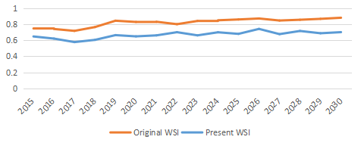
Figure 24. Capability of the program
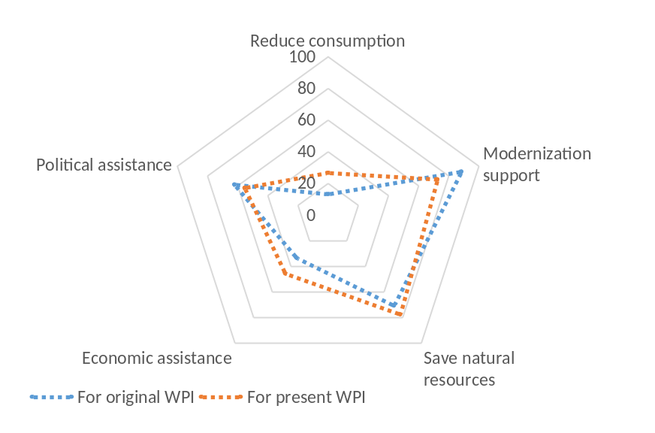

It is worth noticing that the value of WSI without intervention of our model doesn’t perform as good as that with intervention program. It turns out that our program is reasonable and feasible, so the water availability will be largely improved and water scarcity conditions can be mitigated. Hopefully, water may not appear on the list of the most pressing issues.

8. Analysis of the model

8.1 Strengths
- Our model has a strong sense of professional background.
- The results about the models are visible and also the solutions are believable.
- In model 1, we use attribute reduction based on real-valued information system and get a selection of index. Compared to AHP, this method is more objective, thus the result we get is more credible.
- In the invention plan, we considered all effects which has been listed before, and then separated them into different classes with sensitivity analysis.

8.2 Weakness
- Only several years of data are collected in the prediction models, and the measurable data is respectively little, the fitting results existed certain errors.
- As the model would be affected by so many kinds of effects, we can’t make all of them into consideration.

Reference
[1] POPULATION GROWTH OF COUNTIES. http://Population growth – New York counties.htm
[2] New York County Selection Map. http://New York QuickFacts from the US Census Bureau.htm.
[3] Tianshi Zhao. 2002. Discussion on some problems of ground reservoirs, Hydrogeology and Engineering Geology. 1000-3665(2002)05-0065-03.
[4] Jianhua Chen. 2009. Alternative to coal-fired electricity stakeholder win-win path based on the external straw, Xian: xian jiaotong university press.
[5] Sullivan, C.A., Meigh, J.R., Fediw, T., 2002. Developing and Testing the Water Poverty Index: Phase 1 Final Report. Report to Department for International Development. Centre for Ecology and Hydrology, Wallingford.
[6] Streeten, P. 1994. “Human development: Means and ends." American Economics Review 84:232-237.
[7] World Bank Data(http://data.worldbank.org)
[8] Zhongnan Qiu. 2000. Price analysis on the water supply of south-to-north water diversion project center line south-to-north, Yangtze River, 31 -07
[9] WANG Xiaojun; ZHAO Hui; GENG Zhi, Current groundwater exploitation situation and protection countermeasure in Lebanon, Lebanon Water Resources; 2010 13

